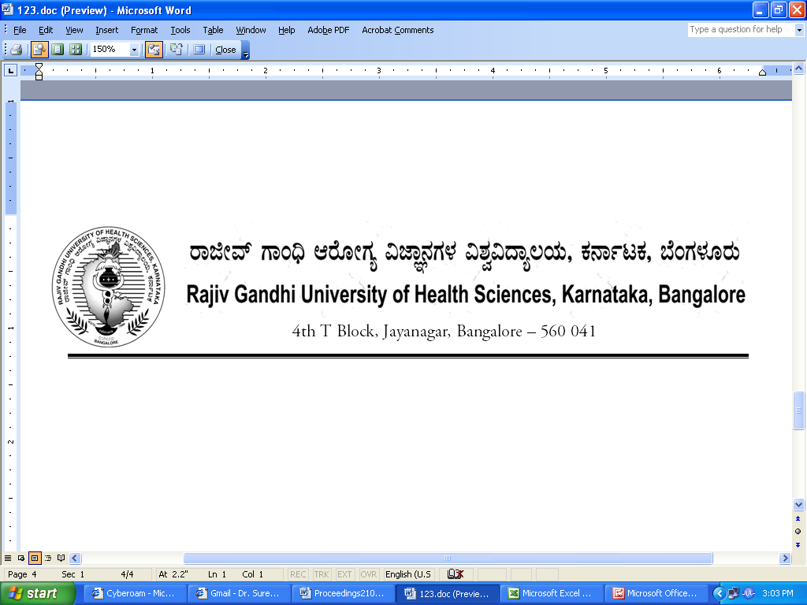

Dr.M.K.Ramesh Ph: 080-26961903, 26961946, Fax: 26961931
Registrar (Evaluation) Email: registrareva @rguhs.ac.in

Reg (E)/Exam/UG-Allied/March – 2018 Date: 03/04/2018

RE-REVISED NOTIFICATION

Sub: | Conduct of UG Allied Courses Examination during March– 2018.
Ref: | - Reg (E)/Exam/UG- /February – 2018, dated 19.12.2017  - Reg (E)/Exam/UG- /February – 2018, dated 29.01.2018  - Reg (E)/Exam/UG- /February – 2018, dated 26.02.2018

In continuation of this office Notification under reference (3) above, the revised time table of BHA examination of March-2018 is re-revised for the following subjects due to University Annual Convocation. The change of dates may be informed to students without fail immediately
Dates as per earlier Time Table
11/04/2018 | Wednesday | 2-00 PM to 05-00 PM | Hospital Support & Utility Services | 1319
12/04/2018 | Thursday | 9-00 AM to 12-00 Noon | Marketing Management | 1323

Re-Revised Dates
17/04/2018 | Tuesday | 2-00 PM to 05-00 PM | Hospital Support & Utility Services | 1319
19/04/2018 | Thursday | 9-00 AM to 12-00 Noon | Marketing Management | 1323

The Principals are hereby instructed to display the Time-Table on their notice boards for information to the students and visit www.rguhs.ac.in (Examination Section Link) for more details.
By Order,

Sd/-
Dr. M.K.Ramesh
Registrar (Evaluation)

